Using the AgPAS Database Exporter

# Quick Links:

[Questionnaire (Funded) Download](https://agnr.umd.edu/admin/structure/webform/manage/questionnaire_funded/results/download):

[Notice of Intent to Submit Download](https://agnr.umd.edu/admin/structure/webform/manage/notice_of_intent_to_submit/results/download)

# Workflow:

Navigate to the “Automation” folder within the AgPAS folder on the S: Drive:

Ensure that the notice_of_intent_to_submit.csv and questionnaire_funded.csv files are up to date (highlighted). These are the files from which the data is taken from. If they are out of date, the most recent submissions may not be shown. To get the most recent data files, go to the links above to download them. **You might need to login.** You’ll see something like this:

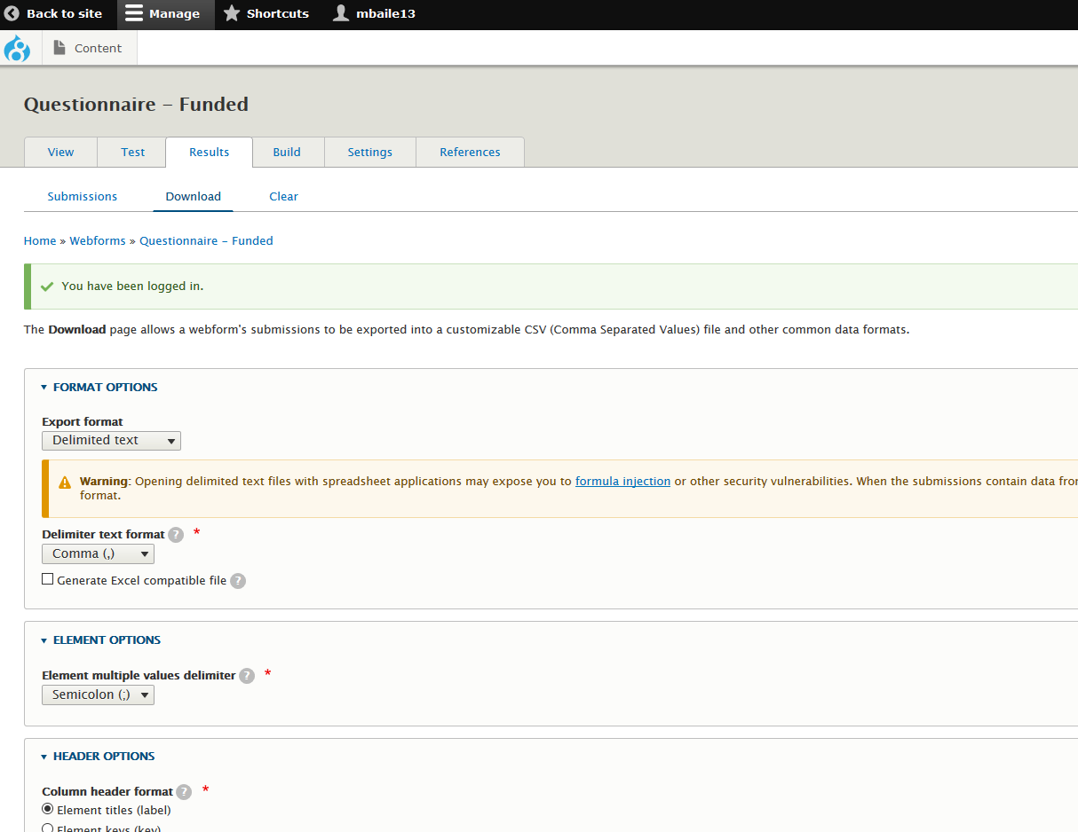

Scroll down, click “Download” at the bottom of the page, and save the updated file on the S: drive in the “Automation” folder. **Do this for the other link above- that is, once for *Notice of Intent*, and once for the *Questionnaire – Funded*.** This makes sure that both data files are up to date.

Once both data files are updated and placed in the same folder as the program, simply double click it. (A dialog box may appear, hit “Run.”) A black box will pop up, indicating that it is working: 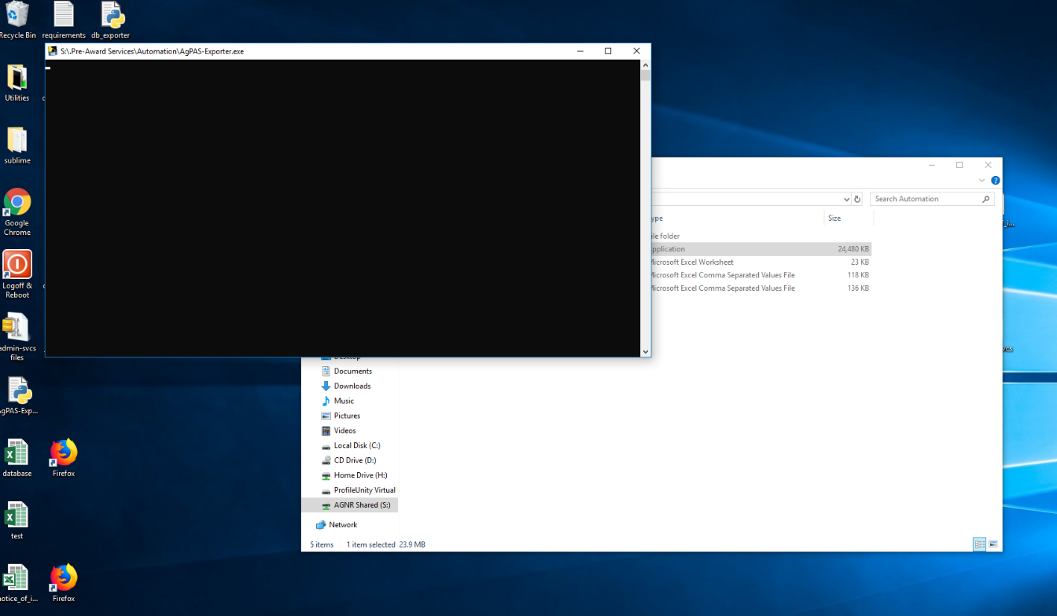

After a while, the box will close, and a new file titled “database_out.xlsx” will appear. This is our nicely formatted database entries! Open it up. It is pre-formatted to match the current layout/scheme of the AgPAS database.

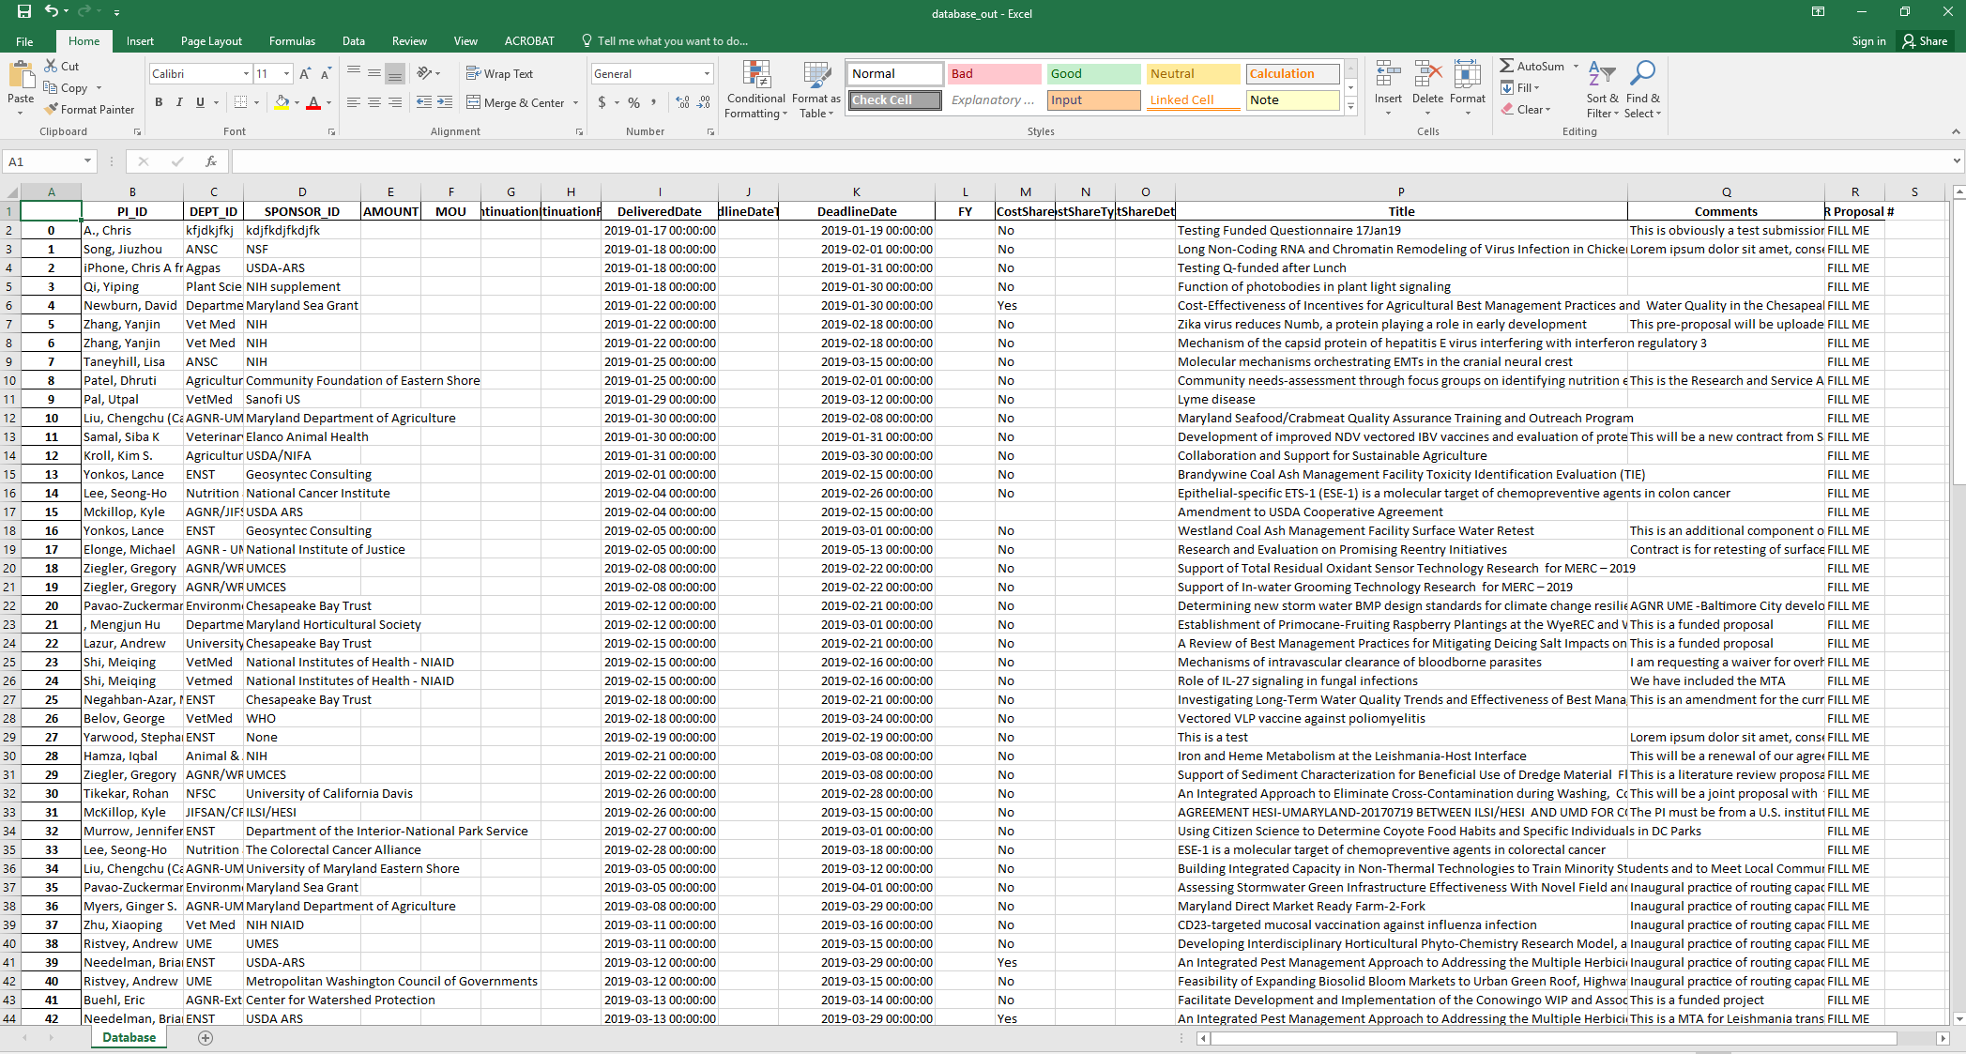

In this spreadsheet, you can find the data from all submitted forms, formatted in a database-friendly scheme. You can now copy/paste the entire row straight into the database!

# For Developers:

<https://github.com/Miskerest/AgPAS-Exporter/>